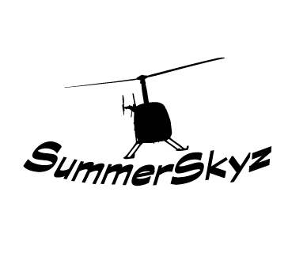
SummerSkyz Flight Training Rates R22 – **NEW**
March 2022

One hour R22 = 325.00 Introductory Flight = 180.00 Solo = 310.00
10 Hour Block $3100.00 $310.00 Per Hour ($150 Savings Per Block)
20 Hour Block $6100.00 $305.00 Per Hour ($400 Savings Per Block)
30 Hour Block $9000.00 $300.00 Per Hour ($750.00 Savings Per Block)
40 Hour Block $11,800.00 $295.00 Per Hour ($1,200.00 Saving Per Block)
50 Hour Block $14,500.00 $290.00 Per Hour ($1,750.00 Savings Per Block)
60 Hour Block $17,100.00 $285.00 Per Hour ($2,400.00 Savings Per Block)
70 Hour Block $19,600.00 $280.00 Per Hour ($3,150.00 Savings Per Block)
80 Hour Block $22,000.00 $275.00 Per hour ($4,000.00 Saving per Block)
(80 hr. - biggest block / lowest rate we can offer)
**********220 lb. weight restriction - maximum seat**********

*All rates include the instructor and fuel surcharge*

